**Kedir Nasir Omer Date: Nov. 28/2022**

**UC SanDiego- Big Data Specialization**

**2.4. Analysis Conclusions**

* **Classifying in KNIME to identify big spenders in Catch the Pink Flamingo**

Below is the completed KNIME workflow

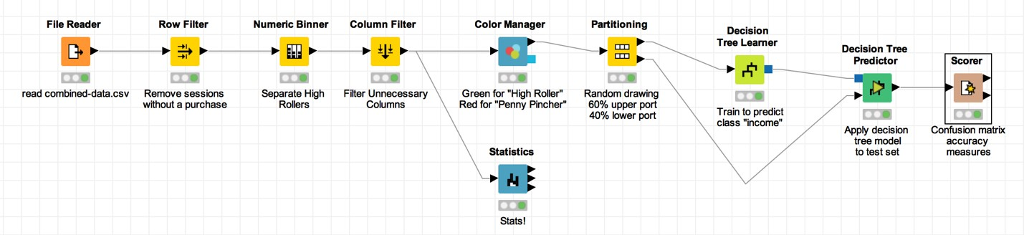

* **PennyPincher vs HighRoller**
* iOS is used by HighRoller users.
* PennyPincher uses Linux, Mac, Android, and Windows.
* **Specifc Recommendation to Increase Revenue**
* Promote iOS HighOller
* Future product creation ought to concentrate on iOS.